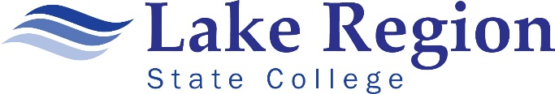
LAKE REGION STATE COLLEGE
Course Assessment Report

Course assessment are the methods developed by individual faculty based on their teaching approach, students, and learning outcomes. The goal of course assessment is to ensure students are learning as expected.
Once per year, fall or spring semester, each instructor will complete the Course Assessment Report form and submit it to Tammy Riggin, Assessment Committee Co-chair, tammy.riggin@lrsc.edu.

Submitted By: | Semester:
Course:

Identify the course objectives and student learning outcomes assessed during this process that were meaningful and measurable.

Specify the General Education Goal(s) assessed during the process.

Indicate the assessment technique used to measure student learning.

Describe the system used to compile and analyze the data.

Identify the changes that were or will be implemented in curriculum and /or teaching methods to improve learning.

Detail how the assessment data was used to improve student learning.

